Zoom – online video conferences (updated 19/03/2020)
Zoom https://zoom.us/ allows you to have an online audio and/or video meeting with friends and family via the internet. We also use Zoom to hold our Church services and meetings. You need a laptop, desktop computer or smartphone/mobile device to use Zoom.
A headset and a second external screen are not essential but if you have them available could make your zoom experience even better.
Zoom should work on all types of computers (MacBook, Chromebooks, Microsoft etc).
Only the host of the meeting needs a Zoom account. Zoom participants do not need a Zoom account.
The main limitation of the free version of Zoom is that the free version only allows group calls for up to 40 minutes (see the end of document for workaround)
Privacy: Please do not record the video meeting without the explicit permission of everybody else on the video call!
Zoom Step by step for participants
by Dr Ingo Schüder, Director Brillianto (www.brillianto.co.uk )
Please send any suggestions for improvements to admin@brillianto.co.uk
This guide is for people who have very little experience in using this kind of technology. This guide covers every single step with screenshots.
If you like to learn by video, please also try out the official Zoom help videos here: https://support.zoom.us/hc/en-us/articles/206618765-Zoom-Video-Tutorials
(this also includes guides for those hosting a Zoom meeting)
Steps
- If you want to use video, rather than just audio, you need a web-camera, either one built into the laptop lid (centre top) or an external camera

- If you have a headset (with or without microphone), plug it into your computer now.

- In your email programme, in the email you have been sent, click on the link with the joining instructions you have been sent. Depending on your email programme, and how the meeting organiser edits the text, your invitation email may look something like this [Note: below, I have blocked out my personal zoom identity with a box ]:
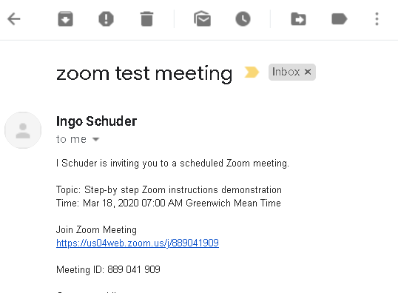

- Double-click on the blue hyperlink to get started

- A window will open automatically in your default internet browser (e.g. google chrome or internet explorer). It looks like this:
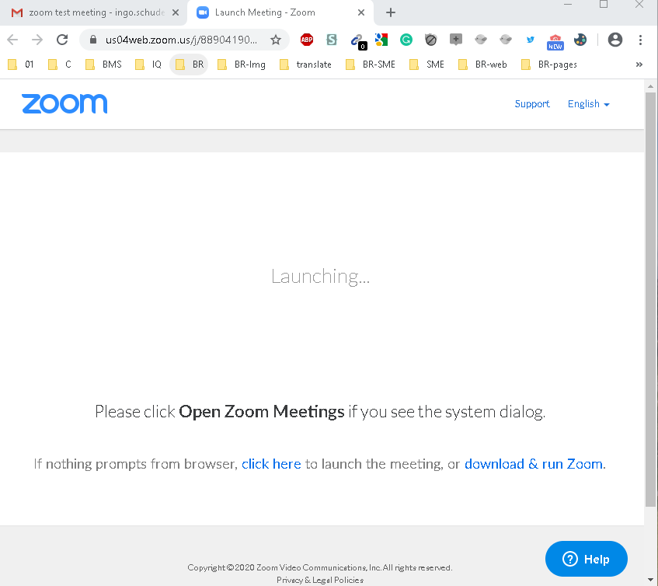

- You now need to download a small programme (10 MB). This will allow you to use zoom. Often this download happens automatically and you will see this in the bottom left corner of your screen:
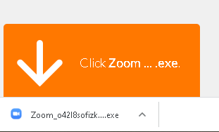

- If this does not happen within 30 seconds, click on “Download and run zoom” and you will see this in the bottom left corner of your screen

- The download time will depend on your broadband speed. Ideally just seconds.

- Double left-click on the file that just downloaded

- Next, you will see this window
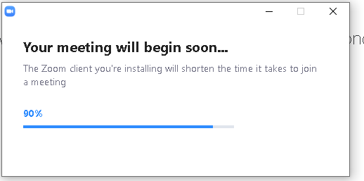
- You may have this symbol flashing at the bottom / in the bottom right corner of your screen:
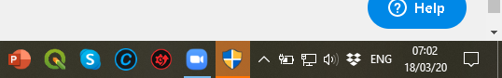

- Click on it. It will ask you: Do you want to allow Zoom to make changes to your System (or something similar). Click “Yes” [no screenshot]

- A Window will open. Enter your name and left-click on “Join Meeting”
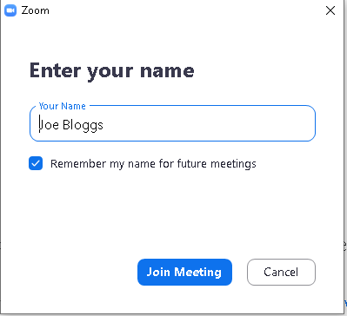

- A window opens. Optional: read the ‘Terms of Service’ and/or or ‘Privavcy policy’. Click on “I agree”

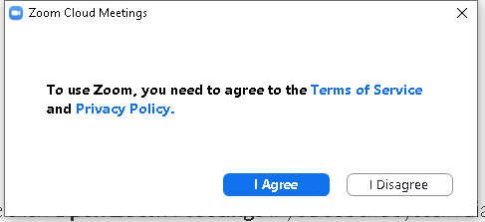

- A window will open looking something like this (at this point only you can see this video of yourself)
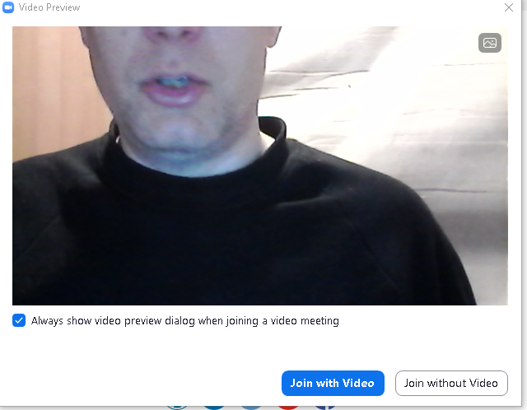

- If you do not see yourself, make sure your video camera is turned on. Improve the light in the room and the position of the camera or the laptop lid position or your own position until you are happy with the image.

- You now have two options – “Join with Video” or “Join without video” (i.e. sound only)

- The following instructions are for video and audio. Ignore all video related steps if you are just using audio.

- A new window will open. Select the 2nd option “Test Speaker and Microphone”
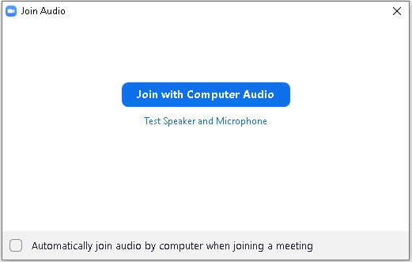

21. A window will open
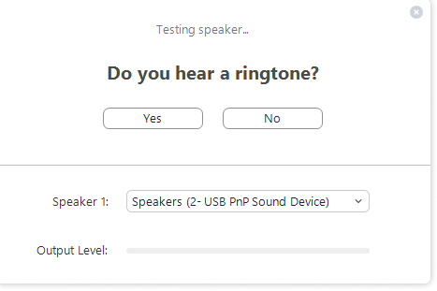
WAIT
before you press YES
- A ringtone will start. Do not press the “Yes” button yet!

- Optional: You may wish to change the volume. One way of doing this is via the loudspeaker symbol in the bottom right corner of your screen.

- Before you do the test, chose the correct audio channel. The default will be the audio system built into your computer. The default is “same as system”

- If you do not have external headphones, leave the default.

- If you do have external headphones, select the correct option from the ‘Speaker 1’ drop-down menu.
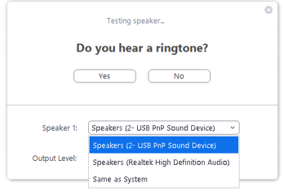
- Once you hear the ringtone (over your headphones), click “Yes” under “Do you hear the ringtone”

- The next window opens. Say something. Anything. You should hear what you just said being played back to you. If so, click “Yes” button (if not, try step 21. Or change settings in step 24.)
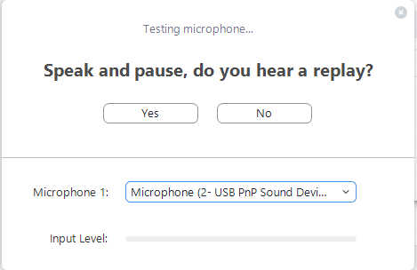
- You will then see this window. Click on “Join Computer with Audio”
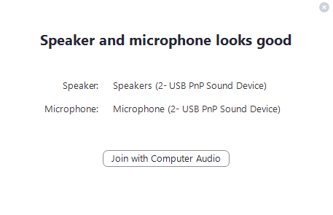
- In the next Window. Click “Join Computer with Audio” again.

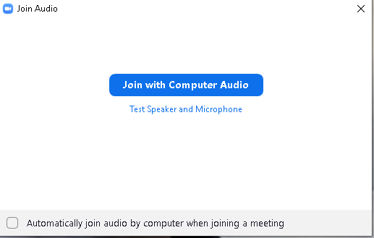

- You are now live in the meeting and other people can see what you are doing and hear what you are saying!

- If you haven’t already optimised your Zoom screen, do it now! (see step 16.)

- Optional: To maximise the window size click on the square box “Maximise” symbol in the top corner of your computer screen, to maximise the window
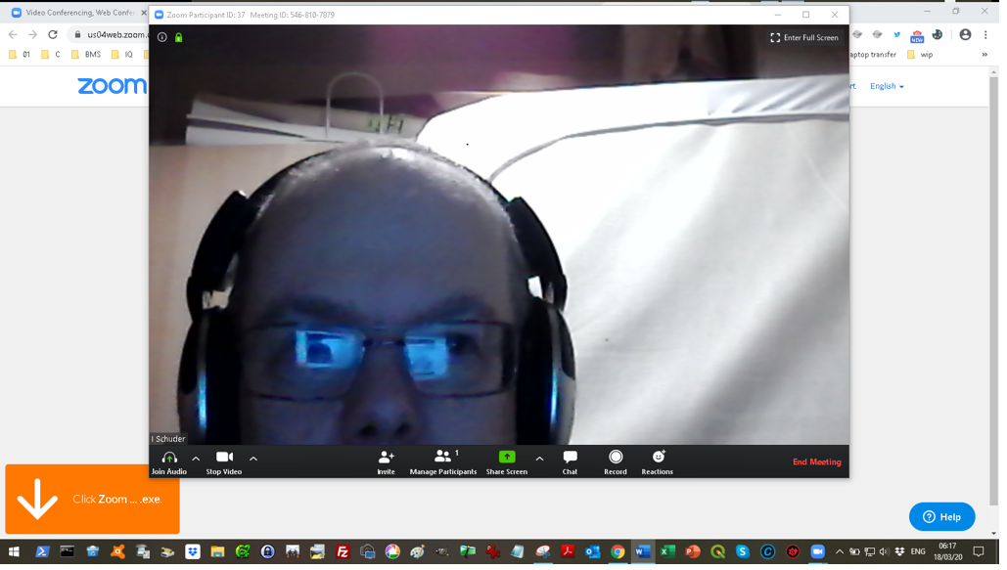
- Optional: hover over the top right corner of your video image and click on “Enter full screen” (you can exit full screen any time by pressing the ESC key on your keyboard (often top left corner of your keyboard or by hovering over the top right corner of your image and click on “Exit full screen” [not shown in screenshot]

- As other people join, you will see their videos (and hear their voices) in smaller screens above your own screen [ no screenshot for this]

- Muting: to avoid too much noise, the Zoom meeting organiser may have put settings to “all participants joining in “mute” (i.e. nobody can hear you when you speak)

- You can mute and unmute yourself by clicking the microphone symbol in the bottom left corner of your Zoom window:

- Note: Reduce the noise in the call by muting yourself when you do not speak!
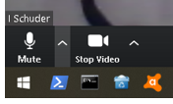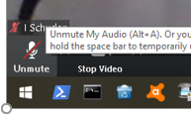
- Optional: if the video quality is poor, because your broadband speed isn’t fast enough, you can choose at any time to “Stop video” (and remain at the meeting in audio only). You may prefer for privacy reasons to stop video (e.g. while eating or blowing your nose)

- Leaving the meeting:
You can leave the meeting any time by pressing the “Leave Meeting” button at the bottom right corner of the Zoom screen.

- Optional: You can use the chat function of zoom by clicking on” Chat”. You need to hover over the bottom part of your Zoom screen: The Zoom menu bar appears. Then click on the word ‘Chat’ or the voice bubble symbol

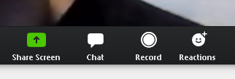

A side window for chat opens on the right-hand side of the zoom screen. You can choose to chat to everyone or just one other caller on the zoom meeting (Use the ‘To’ dropdown menu and select a name. The default is to chat to everybody. Just start typing in the box saying ‘Type message here’. Press ‘retur/Enter’ key on your keyboard to send
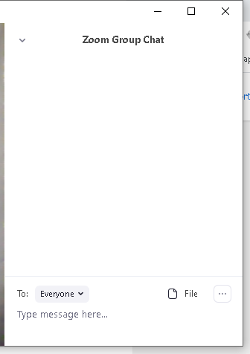

- Optional: You can applaud another person speaking or give them your thumbs up, by using the function “Reactions” at the bottom of the zoom screen (hover over bottom of screen first, then click on ‘Reactions’ or smiley symbol.
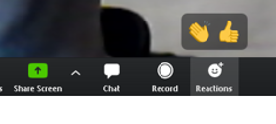

- Privacy: Please do not record the video meeting without the explicit permission of everybody else!

- Optional: You can share a PowerPoint or another file or your screen by clicking the green “Share Screen” button in the centre of the bottom of the Zoom screen (people can see your screen instead of you/ your video feed)

There are alternatives to Zoom including Skype, Microsoft teams, video chat via WhatsApp, video chat via Instagram.

Have a great meeting and be safe!

Ingo Schüder

